RDP to AWS windows instance

Task : Create a windows Vm machine in AWS and connect with RDP open CMD in windows share the about system info

Created a windows machine

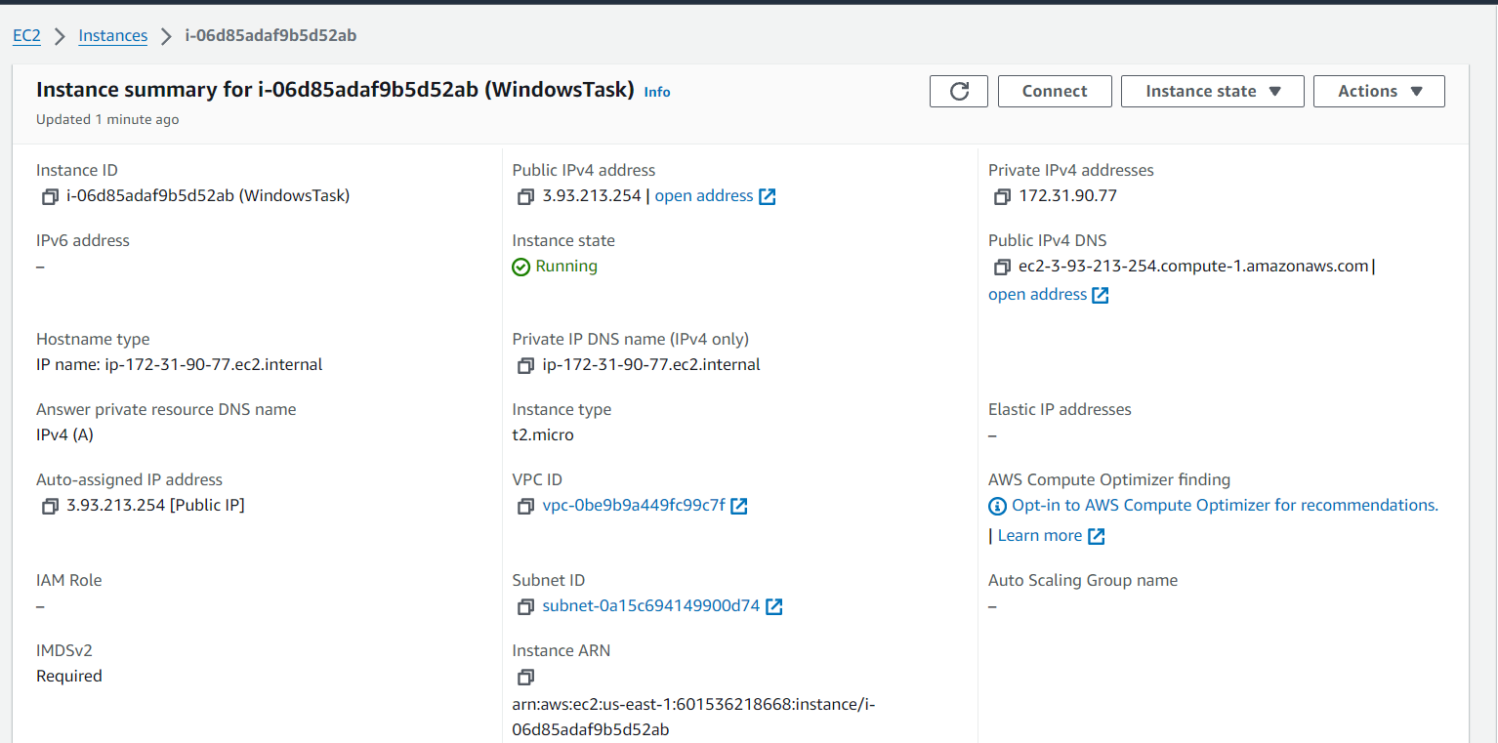

Using RDP login to windows instance

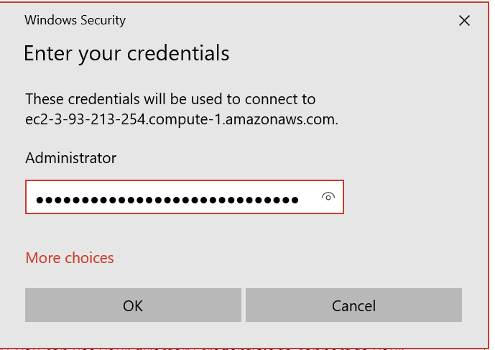

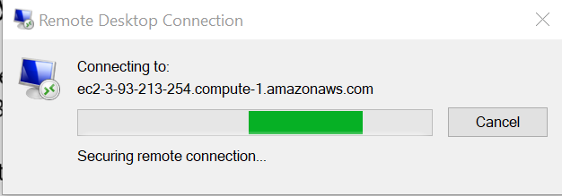

From cmd of ec2 instance

